***Filipino barbecue***

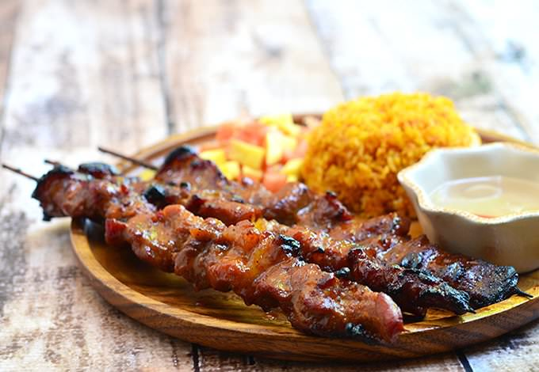

**Filipino pork barbecue is popular street food in the Philippines as well as a regular mainstay at parties and special gatherings. Commonly peddled at street corners on makeshift grill carts, these delectable pork skewers are also widely enjoyed as a viand with hefty servings of rice and as portable appetizers to complement ice cold beer.**

***Ingredients***

* 6 pound pork, sliced to 1-inch wide and ¼ inch thick
* 2 liters of soda
* 4 cups of soy sauce
* 4 cups of vinegar
* 2 tablespoons of ground black pepper
* 6 cups brown sugar
* 2 cups of garlic, peeled and minced
* 5 thai chili peppers or 2 jalapenos, minced
* 2 cups of oyster sauce
* ½ cup of sesame oil

***How to make Filipino pork barbecue***

* **Soak the bamboo skewers in water for at least 30 minutes before skewering the meat so they don’t burn during grilling**
* **The success of your pork barbecue is the half of the marinade and half the type pork you use. For great texture and flavor, chose a cut with adequate ribbons of fat such as pork butt. Make sure to slice very thin, uniform sizes to ensure even cooking.**
* **Drain the sliced pork well and pat dry so the excess liquid does not dilute the marinade. For food safety, I discard the marinade and make a fresh batch of basting sauce. If you want to use the marinade, bring to a boil for a good 10 to 15 minutes to reduce the marinade and to kill off any bacteria from the raw meat.**
* **To prevent excessive charring and to prevent the meat from burning before fully cooked, grill the pork FIRST for a few minutes on each side before basting. Once the meat changes color, you can start brushing with the sauce.**
* **For great depth of flavor, marinate the meat for at least 4 hours or overnight for best results. I don’t recommend marinating the meat longer than overnight as the acids in the marinade will break down the protein fibers of the meat.**